身體活動、電腦使用與睡眠是否能解釋學生 BMI 百分位數的差異？
工管三乙 112370206 黃立帆

1. Research Question
Among U.S. high school students in the YRBS 2007 dataset, is BMI percentile associated with physical activity days after adjusting for computer use, sleep, sex, and age?

2. Variables
Role | Dataset variable | Project variable | Description
Outcome | BMIPCT | bmi_percentile | BMI percentile based on age and sex.
Main predictor | PhysicalActivity5OrMoreDays | physical_activity_days | Number of days physically active for at least 60 minutes in the past 7 days.
Control | ComputerUse | computer_use_hours | Approximate hours of non-school computer/video game use on an average school day.
Control | Sleep | sleep_hours | Approximate hours of sleep on an average school night.
Control | WhatIsYourSex | female | Female indicator: male = 0, female = 1.
Control | HowOldAreYou | age_years_approx | Approximate age in years.

3. Data Preparation
The original dataset contained 14,041 rows and 103 columns. I selected the variables needed for the research question, renamed them, and recoded ordinal survey answers into approximate numeric values. After removing rows with missing values in the selected variables, the final analysis sample contained 11,287 students.

4. Statistical Method
The approved method used in this project is multiple linear regression. This method is suitable because the outcome variable, BMI percentile, is numeric and the model can include several predictors at the same time.
Model: BMI percentile = b0 + b1(activity days) + b2(computer use hours) + b3(sleep hours) + b4(female) + b5(age) + error

5. Results
The model used 11,287 complete observations. The R-squared value was 0.008, which means the predictors explained only a small amount of variation in BMI percentile.
Variable | Coefficient | Std. Error | t value | p value | CI Lower | CI Upper
Intercept | 94.2177 | 3.9899 | 23.6138 | 0.0 | 86.3967 | 102.0386
Physical activity days | -0.267 | 0.1032 | -2.5867 | 0.0097 | -0.4693 | -0.0647
Computer use hours | -0.1421 | 0.1715 | -0.8288 | 0.4072 | -0.4782 | 0.194
Sleep hours | -0.815 | 0.1965 | -4.1472 | 0.0 | -1.2001 | -0.4298
Female (vs male) | 3.4422 | 0.535 | 6.4334 | 0.0 | 2.3934 | 4.491
Age (approx years) | -1.4916 | 0.2154 | -6.926 | 0.0 | -1.9137 | -1.0695
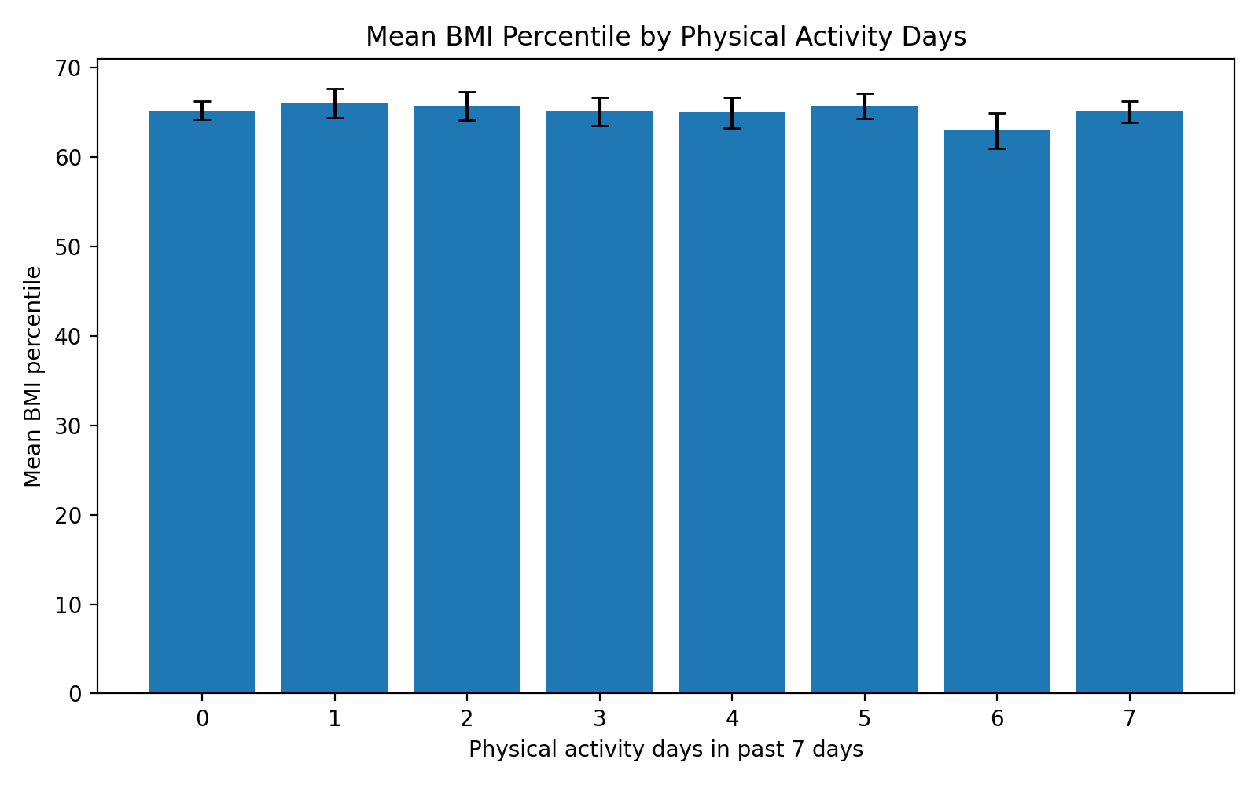
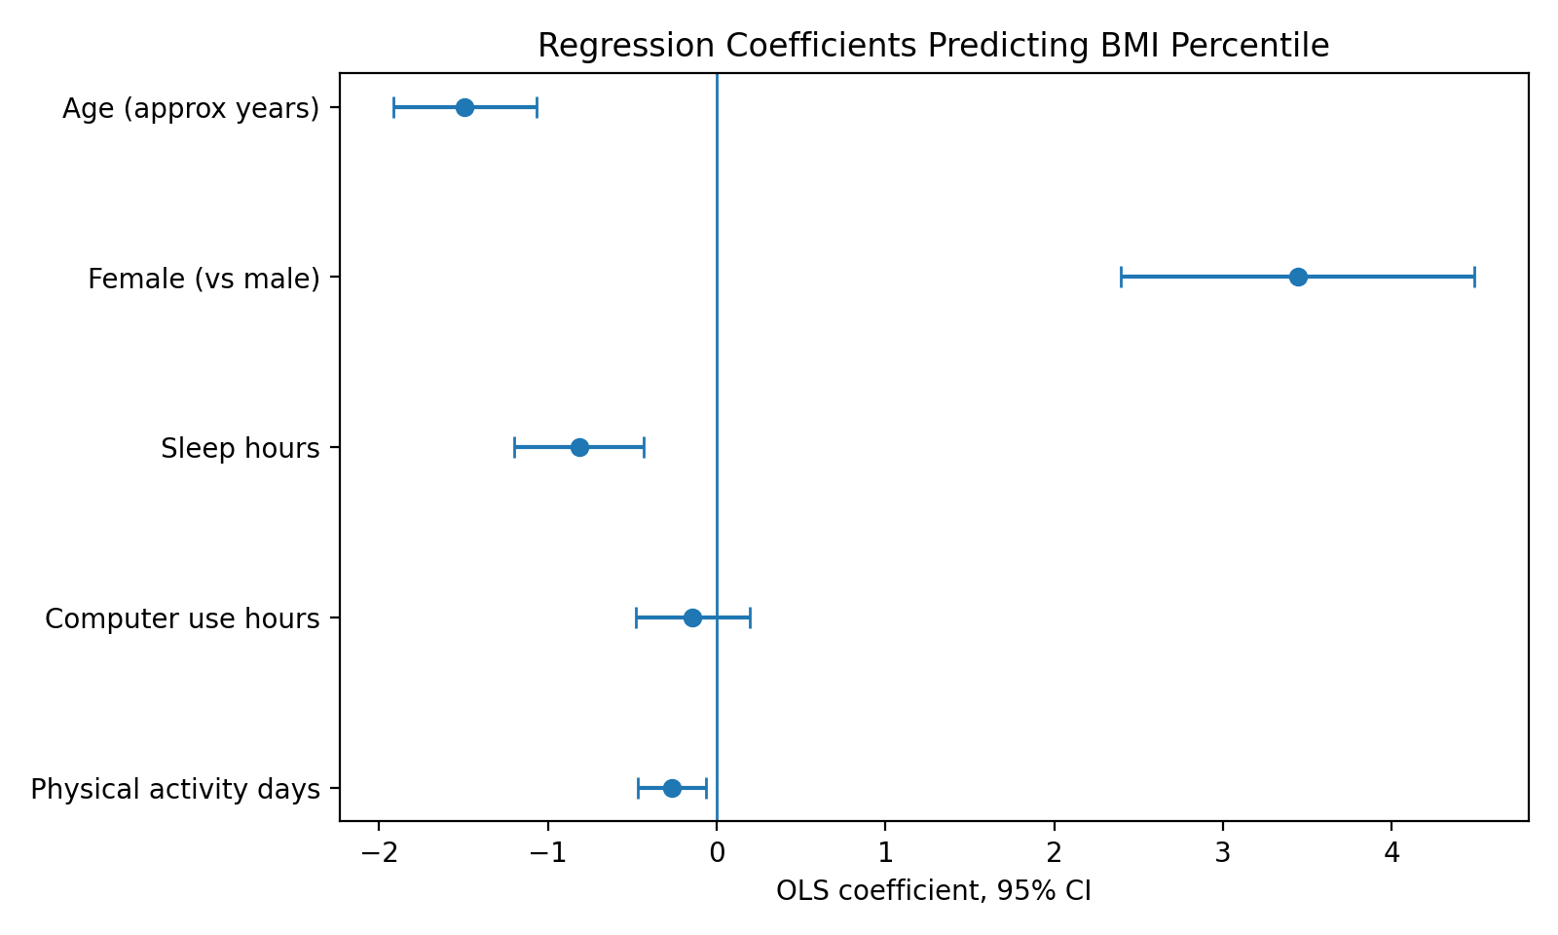

6. Interpretation and Conclusion
After adjusting for computer use, sleep, sex, and age, each additional physically active day was associated with -0.27 BMI percentile points. The p-value was 0.0097, so the association was statistically significant in the unweighted OLS model.
However, the practical effect was small. The low R-squared shows that these variables do not explain most differences in BMI percentile. The conclusion is that physical activity days have a weak negative association with BMI percentile, but BMI is influenced by many other factors not included in this model.

7. Limitations
This project uses observational survey data, so the results show association only and cannot prove causation. Some survey answer categories were recoded into approximate numeric values, which simplifies the original responses. Also, the main regression is unweighted OLS for course clarity; a weighted sensitivity result is provided in the output tables.

8. Submission Checklist
- Jupyter Notebook and code
- Cleaned data
- Figures and tables
- One-page infographic summary
- README.md with repository and YouTube links
- English presentation video script

